

**NATIONAL INSTITUTE OF TECHNOLOGY WARANGAL**

**HUMAN FOLLOWING ROBOT**



**BATCH NUMBER:** 19

**FACULTY:**

Dr. J. Ravi Kumar Sir

**TEAM MEMBERS:**

TANNERU BHAVYA - 21ECB0B60

POTLURI SRI VARSHA - 21ECB0B44

RAMYA LAKSHMI SEGGAM - 21ECB0B55

**Aim:**

To design a Human Following Robot

**Apparatus:**

|  |  |  |  |
| --- | --- | --- | --- |
| **S. No** | **Materials** | **Quantity** | **Cost** |
| 1. | Robotic kit | 1 | 550 |
| 2. | Motor driver | 1 | 150 |
| 3. | Servo Motor | 1 | 150 |
| 4. | Arduino | 1 | 850 |
| 5. | Arduino Cable | 1 | 80 |
| 6. | Ultrasonic Sensor | 1 | 150 |
| 7. | 9 Volt Battery | 2 | 40 |
| 8. | IR Sensors | 2 | 300 |
| 9. | Jumper Wires | 10 | 20 |
| 10. | Male-Female Wires | 10 | 20 |
| 11. | 3 Pin Switch | 1 | 10 |
| 12. | Double sided plaster | 1 | 10 |

**ROBOTIC KIT**

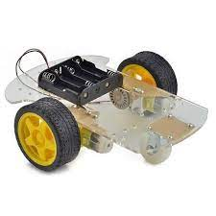

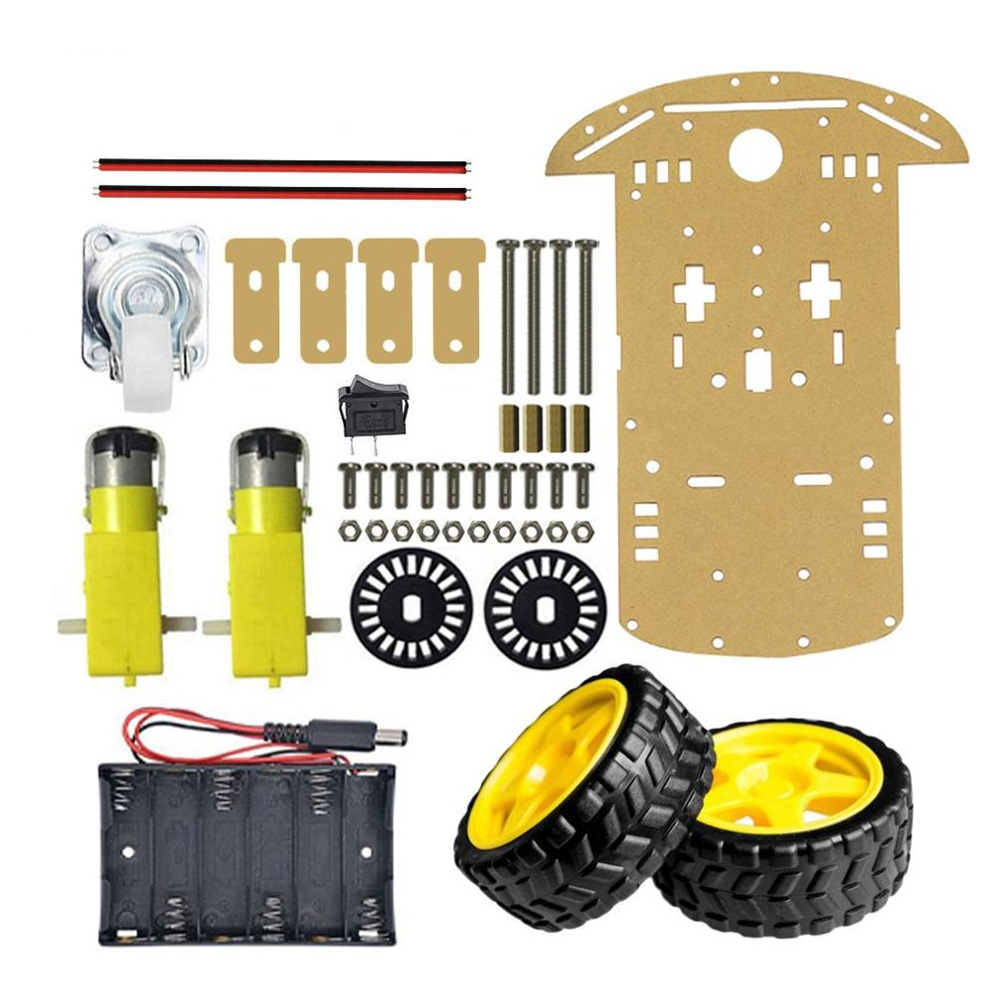

It consists of 2 motors, 2 wheels ,12 screw, 12 Nuts and Battery Clip.

**Motor**

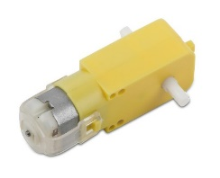

An electric motor is a device used to transform electricity into mechanical energy opposite to an electric generator. They operate employing principles of electromagnetism, which determines that a force is applied when an electric current is present in a magnetic field. Motors have many various working parts in order for them to continually rotate, providing Power as needed. Motors can run off of direct current (DC) or alternating current (AC).

The principle of an electric motor is based on the current-carrying conductor which produces magnetic field around it. A current-carrying conductor is placed perpendicular to the magnetic field so that it experiences a force.

**MOTOR DRIVER**

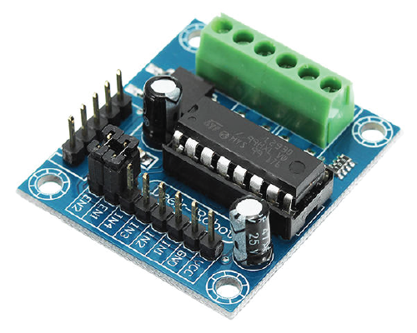

Motor drivers acts as an interface between the motors and the control circuits. Motor require high amount of current whereas the controller circuit works on low current signals. So the function of motor drivers is to take a low-current control signal and then turn it into a higher-current signal that can drive a motor.

**Servo Motor**

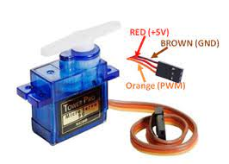

Any electric motor capable of controlling parameters like position and speed is called a servo motor, regardless of how this control is achieved.

Servo Motors control their angle of rotation based on their external input.

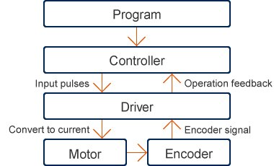

**CONTROL MECHANISM OF SERVO MOTOR**

**WORKING MECHANISM OF SERVO MOTOR**

It consists of three parts:

1. Controlled device
2. Output sensor
3. Feedback system

A servo consists of a Motor (DC or AC), a potentiometer, gear assembly, and a controlling circuit. First of all, we use gear assembly to reduce RPM and to increase torque of the motor. Say at initial position of servo motor shaft, the position of the potentiometer knob is such that there is no electrical signal generated at the output port of the potentiometer. Now an electrical signal is given to another input terminal of the error detector amplifier. Now the difference between these two signals, one comes from the potentiometer and another comes from other sources, will be processed in a feedback mechanism and output will be provided in terms of error signal. This error signal acts as the input for motor and motor starts rotating. Now motor shaft is connected with the potentiometer and as the motor rotates so the potentiometer and it will generate a signal. So as the potentiometer’s angular position changes, its output feedback signal changes. After sometime the position of potentiometer reaches at a position that the output of potentiometer is same as external signal provided. At this condition, there will be no output signal from the amplifier to the motor input as there is no difference between external applied signal and the signal generated at potentiometer, and in this situation motor stops rotating.

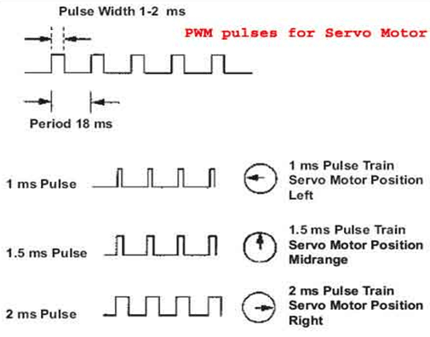

Servo motor works on PWM (Pulse width modulation) principle, means its angle of rotation is controlled by the duration of applied pulse to its Control PIN. Basically servo motor is made up of DC motor which is controlled by a variable resistor (potentiometer) and some gears. High speed force of DC motor is converted into torque by Gears. We know that WORK= FORCE X DISTANCE, in DC motor Force is less and distance (speed) is high and in Servo, force is High and distance is less. The potentiometer is connected to the output shaft of the Servo, to calculate the angle and stop the DC motor on the required angle.

**ARDUINO**

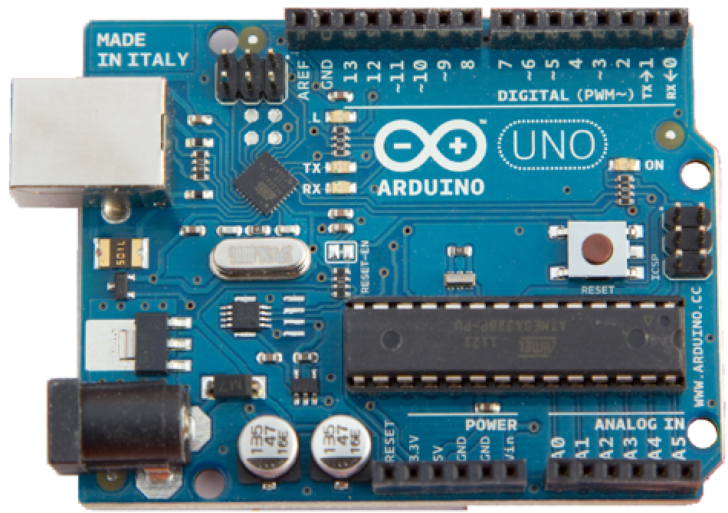

Arduino is an open-source platform used for building electronics projects. Arduino consists of both a physical programmable circuit board (often referred to as a microcontroller) and a piece of software, or IDE (Integrated Development Environment) that runs on your computer, used to write and upload computer code to the physical board. The Arduino platform has become quite popular with people just starting out with electronics, and for good reason.

**ULTRASONIC SENSOR**

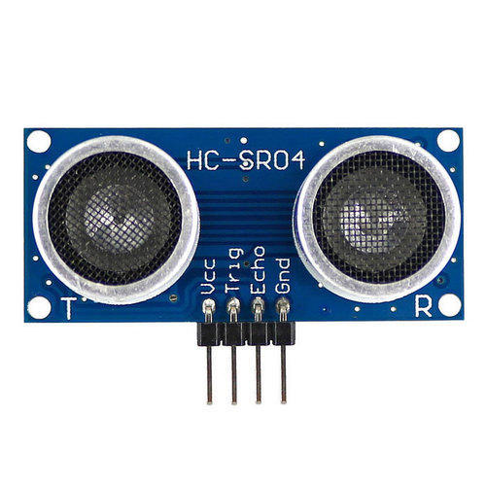

The ultrasonic sensor (or transducer) works on the same principles as a radar system. An ultrasonic sensor can convert electrical energy into acoustic waves and vice versa. The acoustic wave signal is an ultrasonic wave traveling at a frequency above 18kHz. The famous HC SR04 ultrasonic sensor generates ultrasonic waves at 40kHz frequency.

Typically, a microcontroller is used for communication with an ultrasonic sensor. To begin measuring the distance, the microcontroller sends a trigger signal to the ultrasonic sensor. The duty cycle of this trigger signal is 10µS for the HC-SR04 ultrasonic sensor. When triggered, the ultrasonic sensor generates eight acoustic (ultrasonic) wave bursts and initiates a time counter. As soon as the reflected (echo) signal is received, the timer stops. The output of the ultrasonic sensor is a high pulse with the same duration as the time difference between transmitted ultrasonic bursts and the received echo signal.

**9 VOLT BATTERY**

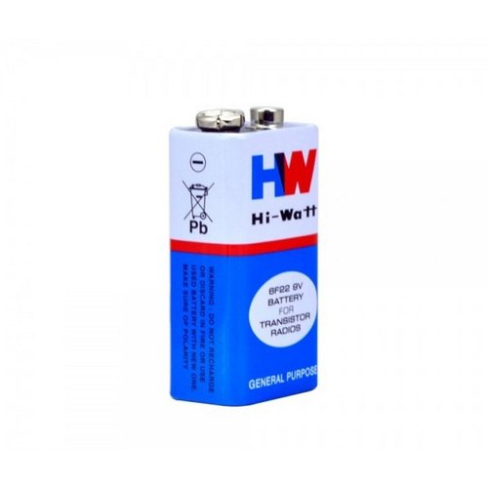

**IR SENSORS**

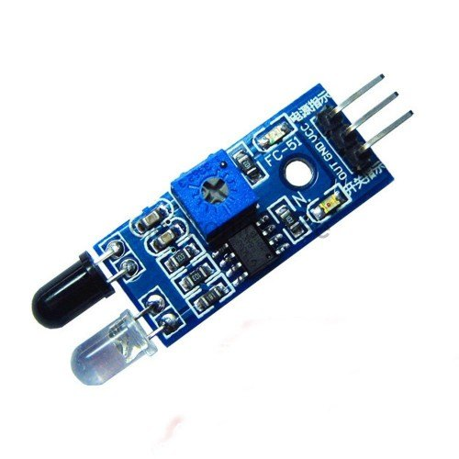

IR sensor is an electronic device, that emits the light in order to sense some object of the surroundings. An IR sensor can measure the heat of an object as well as detects the motion. Usually, in the infrared spectrum, all the objects radiate some form of thermal radiation. These types of radiations are invisible to our eyes, but infrared sensor can detect these radiations.

The emitter is simply an IR LED (Light Emitting Diode) and the detector is simply an IR photodiode. Photodiode is sensitive to IR light of the same wavelength which is emitted by the IR LED. When IR light falls on the photodiode, the resistances and the output voltages will change in proportion to the magnitude of the IR light received.

There are five basic elements used in a typical infrared detection system: an infrared source, a transmission medium, optical component, infrared detectors or receivers and signal processing. Infrared lasers and Infrared LED’s of specific wavelength used as infrared sources.

**JUMPER WIRES**

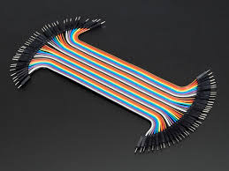

**MALE FEMALE WIRES**

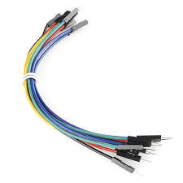

**3 PIN SWITCH**

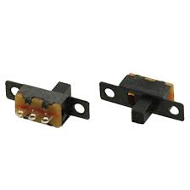

**WORKING PROCEDURE**

First we fix the robotic kit and then we connect servo motor to the Arduino board and the first pin to 3.3 Volt pin in Arduino and then the last to ground and the middle pin is attached to 13th pin of Arduino. We write the motor wheels code such that to move forward motor 1 front should be high and back is low. we write in this manner to fullfill our need.

We write the code for Ultrasonic sensor such that it detects at which distance the object is present. The Trigpin of ultrasonic sensor releases the Ultrasonic waves (based on the time delay we wrote on code) and if it detects the objects the waves will get reflected back and will be received by Echopin.

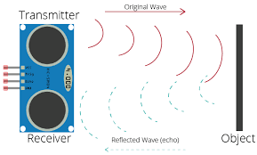

We calculate duration by using the library name Pulsein.

And we calculate the distance by using expression

Speed=distance/Time

We take Speed as the sound wave sound that is 340m/s that is 0.034 cm/s.

Here the calculated distance is the distance covered when wave is transmitted by trigpin and get received by the Echopin. Hence we should divide by 2 to get the object distance.

Therefore distance =duration *0.034 /2

We connect two IR sensors and connect it to Arduino. We know that IR sensors give low signal as output when it detect the object and the light near the output gets on.

We write the code such that if both IR sensors detect object and distance measured from ultrasonic Sensor is greater than zero then the robot should move forward. And when only right IR sensor detects the object then the right motor should rotate back and left motor should turn right to follow the object (Human).

When only Left IR sensor detects object then the left motor should rotate back and right wheel to front so that robot follows the object. If both motors don’t detect anything then the robot should stop.

In code we wrote such that the robot rotates it’s head in 180 degrees only once to see the surroundings.

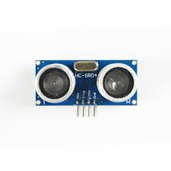

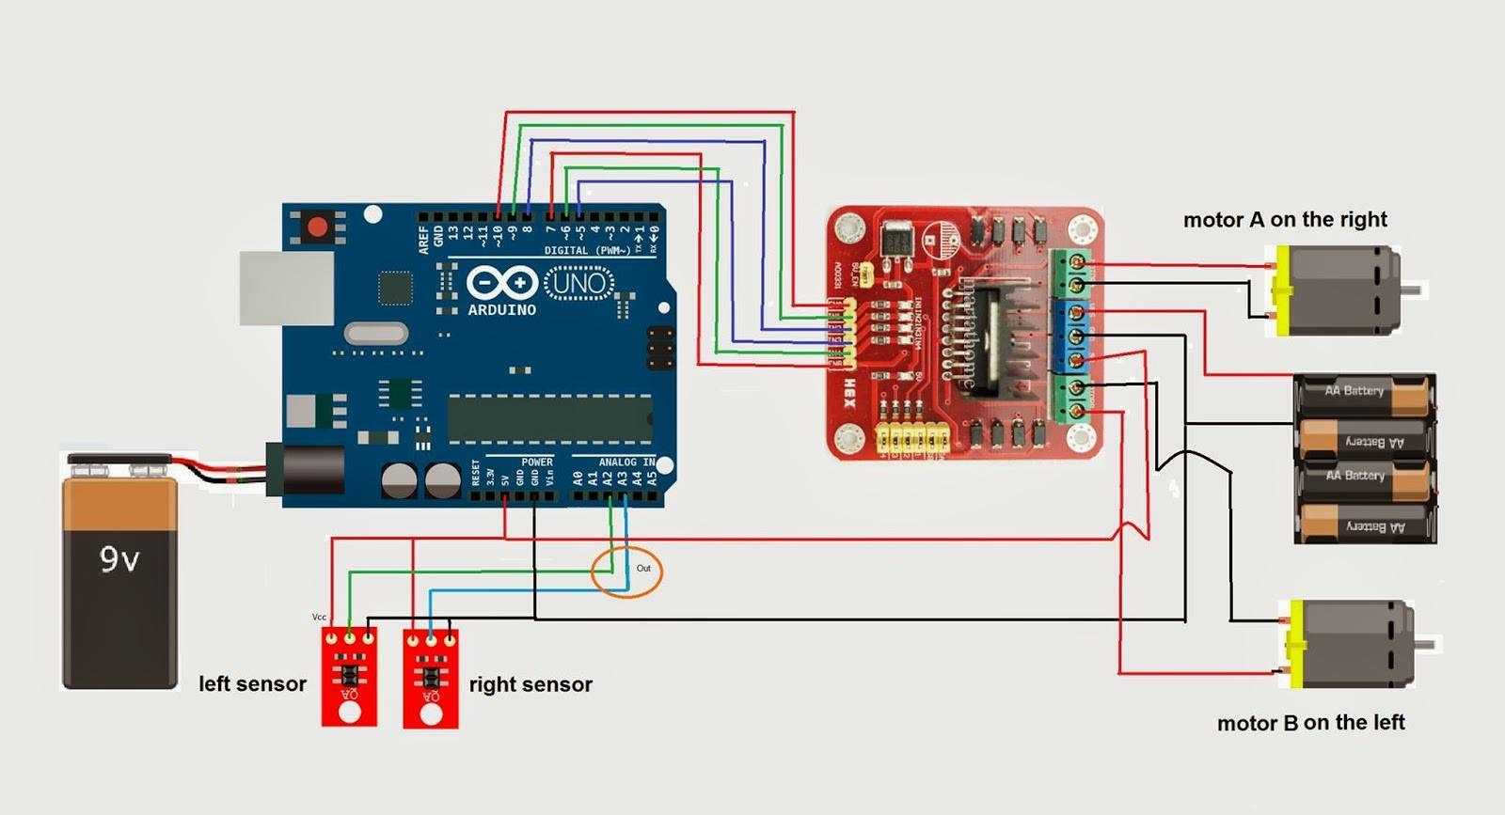

**APPLICATIONS OF HUMAN FOLLOWING ROBOT**

1. Human Following Robot is really in vast Universities like National Institute of Technology (NITW). When visitors or juniors visit NITW for the first time then this Robot can help them know the Departments, Labs and Hostels.

2.This type of robots can be used in Restaurants for serving and welcoming the Customers.

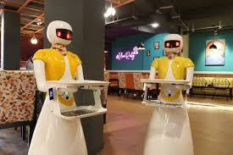

**CODE:**

#include<Servo.h>

Servo s;

int pos=0;

#define enable1 1

#define enable2 2

int Motor1speed=128;

int Motor2speed=128;

int motor1a=8;

int motor1b=9;

int motor2b=10;

int motor2a=11;

int trigpin=7;

int echopin=6;

long duration;

int distance;

#define LEFT A0

#define RIGHT A3

void setup() {

// put your setup code here, to run once:

s.attach(13);

for(pos=90;pos<=180;pos++)

{

s.write(pos);

delay(15);

}

for(pos=180;pos>=0;pos--)

{

s.write(pos);

delay(15);

}

for(pos=0;pos<=90;pos++)

{

s.write(pos);

delay(15);

}

pinMode(enable1,OUTPUT);

pinMode(enable2,OUTPUT);

pinMode(8,OUTPUT);

pinMode(9,OUTPUT);

pinMode(11,OUTPUT);

pinMode(12,OUTPUT);

pinMode(7,OUTPUT);//trigpin

pinMode(6,INPUT);//echopin

pinMode(RIGHT,INPUT);//ir sensor

pinMode(LEFT,INPUT);

//Serial.begin(9600);//for serial communication

}

void loop() {

// put your main code here, to run repeatedly:

//we will declare which pin goes when hight and low

digitalWrite(trigpin,LOW);

delay(2);

digitalWrite(trigpin,HIGH);

delay(10);

digitalWrite(trigpin,LOW);

duration = pulseIn(echopin,HIGH);//this reads the pin which high or low

distance = (duration*0.034/2);

int Rightval=digitalRead(RIGHT);

int Leftval=digitalRead(LEFT);

//for forward

if((Rightval == 0) && (Leftval==0) &&(distance>=0 && distance<=30))//distance in cm

{

digitalWrite(motor1a,HIGH);

digitalWrite(motor1b,LOW);

digitalWrite(motor2a,HIGH);

digitalWrite(motor2b,LOW);//for fast turn

analogWrite(enable1,Motor1speed);

analogWrite(enable2,Motor2speed);

}

// detects object at right so gives low signal that is 0

else if((Rightval==0) && (Leftval==1))

{

digitalWrite(motor1a,LOW);

digitalWrite(motor1b,HIGH);

digitalWrite(motor2a,HIGH);

digitalWrite(motor2b,LOW);//for fast turn//

delay(15);

analogWrite(enable1,Motor1speed);

analogWrite(enable2,Motor2speed);

}

// detects object at left so gives low signal that is 0

else if((Rightval==1) && (Leftval==0))

{

digitalWrite(motor1a,HIGH);

digitalWrite(motor1b,LOW);

digitalWrite(motor2a,HIGH);

digitalWrite(motor2b,HIGH);

delay(15);

analogWrite(enable1,Motor1speed);

analogWrite(enable2,Motor2speed);

}

//stop

else if((Rightval==1) && (Leftval==1))

{

digitalWrite(motor1a,LOW);

digitalWrite(motor1b,LOW);

digitalWrite(motor2a,LOW);

digitalWrite(motor2b,LOW);

}

}